|  |  |  |  |  |  |  |  |  |  |  |
| --- | --- | --- | --- | --- | --- | --- | --- | --- | --- | --- |
|  |  | | **Daffodil International University** | | | | |  |  | |
|  |  | | | http://4.bp.blogspot.com/-SotLIkzmscA/UqQLE9BjdPI/AAAAAAAAARc/-SF46qFfVE0/s1600/daffodil-international-university-logo.png | | |  | |  | |
|  | | | | | | | | | | |
| **Employee Attendance management system(eams)** | | | | | | | | | | |
|  | | | | | | | | | | |
| Course Project  Software Engineering Project 2: Web Programming  Course Code: SWE332 | | | | | | | | | | |
|  | | NAME | | | **:** | Md. Rajib Mia | | | |  |
| ID | | | **:** | 143-35-761 | | | |
| DEPARTMENT | | | **:** | Software Engineering | | | |
| Faculty of Science and Information Technology | | | | | | | |
|  | | |  |  | | | |
| December 2017 | | | | | | | | | | |

Table of Contents

**Chapter 1** 1

**1.** **Introduction** 2

***1.1*** ***About the System*** 2

**1.2** **Purpose**2

**1.3** **Scope**2

**1.4** **Vision**2

**1.5** **Why this system is necessary?**2

**Chapter 2** 3

**2.** **System Analysis** 4

**2.1** **Use Case Model**4

**2.2** **Actor Goal List**4

**2.3** **Use Case Description (Brief)**4

2.3.1 Manage Employee4

**2.3.2 Manage Attendance----------------------------------------------------------------------- 5**

**2.4** **Use Case Description (Detailed)**6

2.4.1Manage Employee**6**

2.4.2Manage Attendance**6**

**2.5** **System Sequence Diagrams**7

2.5.1Manage Employee(Success Scenario)**7**

**2.5.2** Manage Employee(Failure Scenario)**8**

**2.5.3** Manage Attendance (Success Scenario)**9**

**2.5.4** Manage Attendance (Failure Scenario)-------------------------------------------------- **10**

**2.6** **Domain Model** *-------------------------------------------------------------------*11

***2.7* Activity Diagram--------------------------------------------------------------------------------- *12***

**Chapter 3** 13

**3.** **System Design** 14

**3.1** **Sequence Diagrams**14

**3.1.1 Manage Employee -------------------------------------------------------------------------- 14**

**3.1.2 Manage Attendance------------------------------------------------------------------------ 15**

**3.2** **Class Diagram**15

**3.3** **Entity Relationship Diagram**16

**Chapter 4** 17

**4.** **Implementation** 18

**4.1** **Tools &Technologies**18

**4.2** **Project Link**18

**CHAPTER -1**

1. **Introduction:** Attendance management system is software developed for daily employee attendance in any institution, organization, industry. It has lot of facilities as like all employees attendance has been recorded according to particular day. This system is also help in eligibility criteria of a employee.
   1. **Employee Attendance Management System.**
   2. **Purpose:** Employee attendance management system’s main purpose is to computerized the tradition way to taking attendance. For generating this software attendance report has been showed after month which is helpful for any organization.
   3. **Scope:** The scope of the project is the system on which the software is installed the project is developed as a web application. This software can use any particular company. Later this application will be modified.
   4. **Vision**: In present technical era should have some best perspective about this system. If most organization use this type of system they can easily handle all day’s employee’s attendance’s .I want to much modify this system in future also I want to convert this system in android application.
   5. **Why this system is necessary:** In past attendance would taken with manually in excel or notebook. Now for revolution of technology this type of system much necessary for any institution, organization. Institution can smartly handle employee’s attendance by using this software system.

**Chapter 2**

1. **System Analysis.**

**2.1) Use Case Model:**

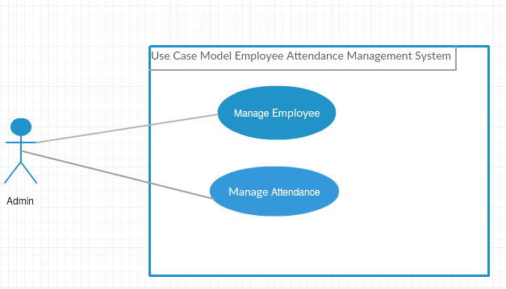

**2.2)**  **Actor Goal List:**

* Admin can add, delete, update employees all information.
* Admin can also view all employees’ information.
* Admin can take attendance according to date.
* Admin can update, delete attendance information.

**2.3)** **Use case description**

**2.3.1) Manage Employee:**

* After login admin can manage employees all data by adding, deleting and updating.
* Admin also view all employees’ data and he can also change all data.

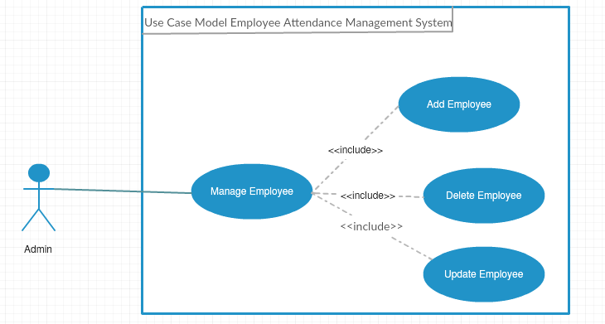

**2.3.2) Manage Attendance:**

* Admin can take attendance according to date.
* Admin can update attendance history.
* Admin can view all attendance history according to date.

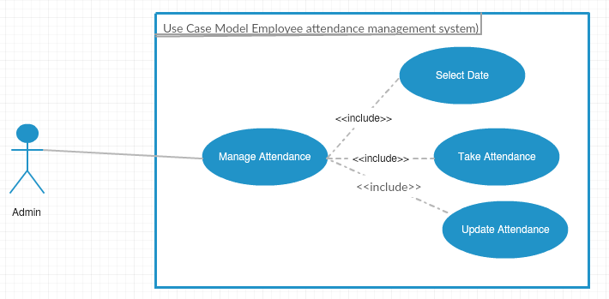

**2.4) Use Case Description Detailed**

**2.4.1) Manage Employee:**

|  |  |  |
| --- | --- | --- |
| Use Case Id | 1 | |
| Use Case Name | Manage Employee | |
| Primary Actor | Admin | |
| Goal | Make ensure to add employee. | |
| Pre Condition | After successfully login able to add employee. | |
| Post Condition | After adding employee admin can modify if necessary. | |
| Main Success Scenario | **Actor** | **System** |
| 1) After logged in admin can add employee.  2) Submit to server.  3) Admin can able to see all employee lists. | 1.1) System gives confirmation message.  2.1) Server generate confirm message. |
| Failure Scenario | 1) Don’t able to login.  2) Don’t able to add employee.  3) System disables. | |

**2.4.2) Manage Attendance:**

|  |  |  |
| --- | --- | --- |
| Use Case Id | 2 | |
| Use Case Name | Manage Attendance | |
| Primary Actor | Admin | |
| Goal | Make ensure to take employee. | |
| Pre Condition | After successfully add employees and select correct date. | |
| Post Condition | After taking attendance admin can modify if necessary. | |
| Main Success Scenario | **Actor** | **System** |
| 1) After successfully added employee admin can take attendance.  2) Select correct date.  3) Take attendance according to employee serial. | 2.1) System gives confirmation message.  3.1) System generate confirm message as successfully taken attendance. |
| Failure Scenario | 1) Don’t able to select date.  2) Don’t able to take attendance.  3) System disables. | |

**2.5) System Sequence Diagram:**

**2.5.1) Manage Employee (success scenario):**

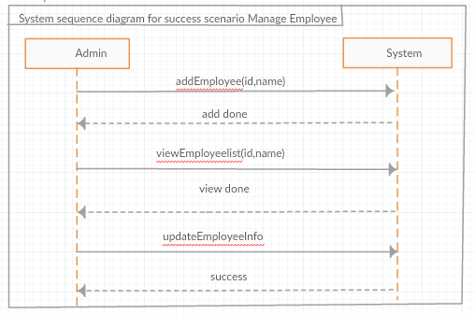

**2.5.2) Manage Employee (Failure scenario):**

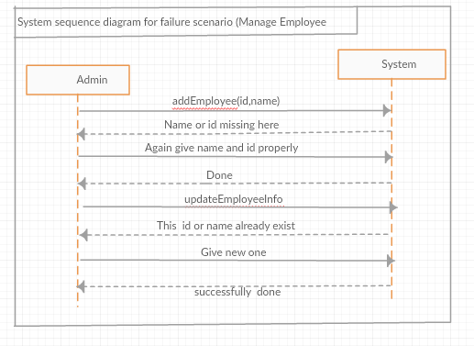

**2.5.3) Manage Attendance (success scenario):**

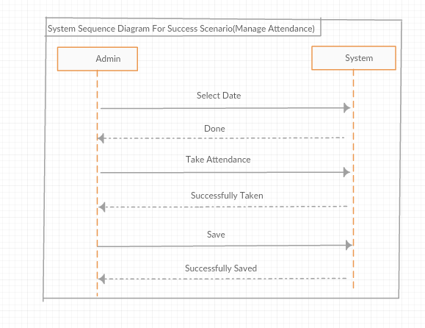

**2.5.4) Manage Attendance (Failure scenario):**

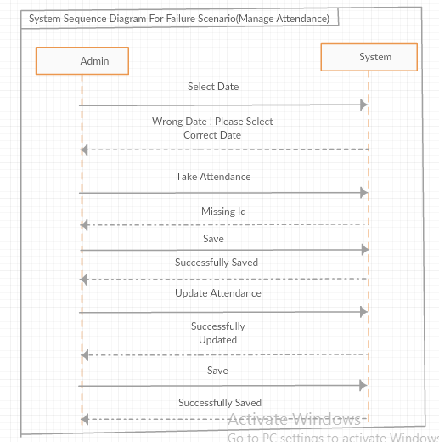

**2.6) Domain Model:**

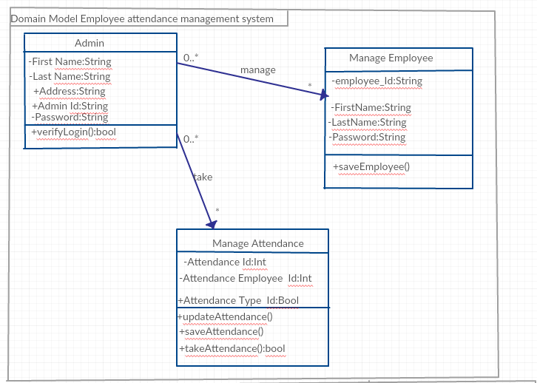

**2.7) Activity Diagram:**

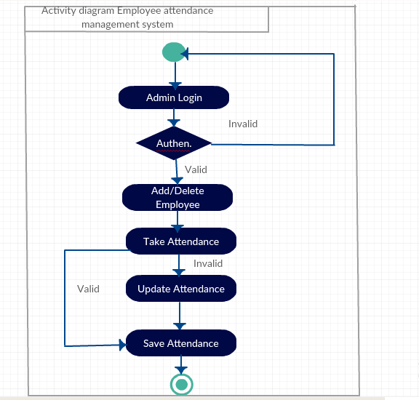

**CHAPTER 3**

1. **System Design:**

**3.1) Sequence Diagram**

**3.1.1) Manage Employee:**

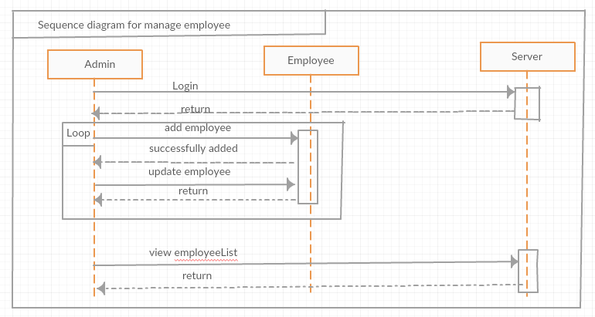

**3.1.2) Manage Attendance:**

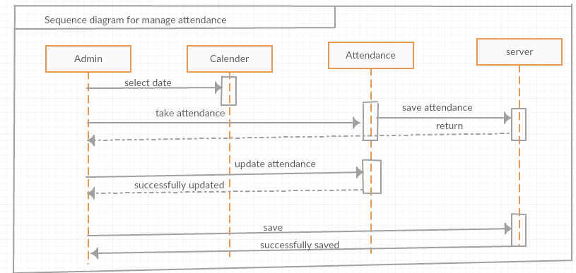

**3.2) Class Diagram:**

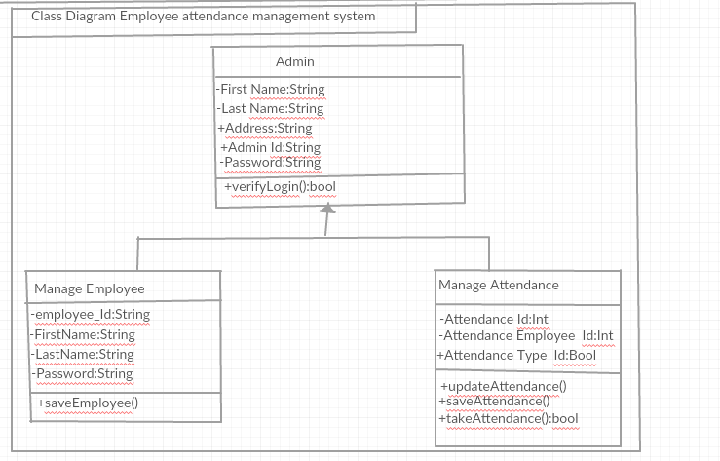

**3.3) Entity Relationship diagram:**

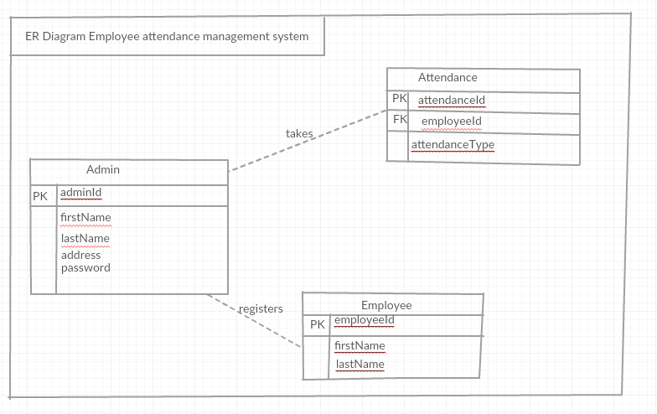

**CHAPTER 4**

1. **Implementation:** Implementation (software) perspective describes software implementations in a particular technology (such as PHP). In the UP, Implementation means programming and building the system, not deploying it. In the implementation phase, the developer builds the components either from scratch or by composition given the architecture document from the design phase and the requirement document from the analysis phase. The architecture document should give guidance. Sometimes, this guidance is found in the requirement document. The implementation phase deals with issues of quality, performance and debugging. The end deliverable of implementation phase is the product itself.

## 5) Tools &Technologies

Following are the tools and technologies used in development of this project:

PHP

Microsoft SQL Server 2008

Creately (online draw tool)

HTML5, CSS, JavaScript, J-query, Twitter bootstrap

## 6) Project Link